Project Development Phase
Model Performance Test

Date | 21 February 2025
Team ID | LTVIP2026TMIDS86052
Project Name | Smart Sorting: Transfer learning for identifying rotten fruits and vegetables
Maximum Marks | LTVIP2026TMIDS86052

Model Performance Testing:
Project team shall fill the following information in model performance testing template.
S.No. | Parameter | Values | Screenshot
 | Model Summary | The proposed model uses MobileNetV2 as the base model followed by Global Average Pooling, Dense, and Dropout layers for classification of Fresh and Rotten fruits and vegetables. The output layer uses Softmax activation for binary classification. | 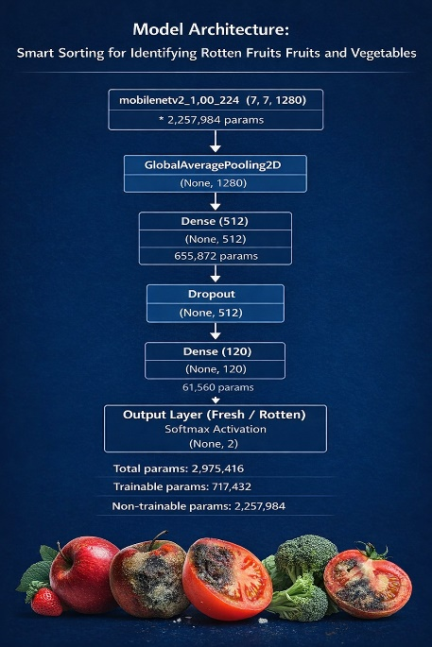
 | Accuracy | Training Accuracy - 94%  Validation Accuracy - 95% | - 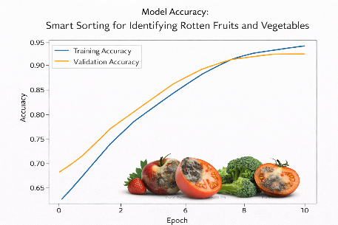
3. | Confidence Score (Only Yolo Projects) | Prediction:  Class = Rotten  Confidence = 93.5% | 